Association Between Periodontitis and Cognitive Impairment or Neurodegenerative Disease: A Systematic Review and Meta-Analysis

Abstract
Objectives: This systematic review and meta-analysis evaluated the association between periodontitis and cognitive impairment or neurodegenerative disease. Data: Quantitative data were extracted from observational studies reporting periodontal exposure, cognitive or neurodegenerative outcomes, effect estimates, confidence intervals, and p-values. Sources: PubMed/MEDLINE, Scopus, and Web of Science were searched for articles published from 2017 to 2025. Study selection: Eligible studies included adult or older adult populations, periodontitis or periodontal disease as the exposure, and cognitive impairment, dementia, Alzheimer disease, Parkinson disease, vascular dementia, or other neurodegenerative outcomes as the outcome. Twelve studies involving 7,335,538 participants were included in the qualitative and quantitative synthesis. The meta-analysis was performed using a random-effects model, and risk of bias was assessed using the Joanna Briggs Institute critical appraisal tools. The pooled effect estimate was 0.15, representing a standardized effect size, with a 95% confidence interval of 0.05-0.26 and p=0.007. Heterogeneity was substantial, with Q(11)=39.24, p<0.001, and I²=72.0%. Conclusions: Periodontitis may be associated with cognitive impairment and neurodegenerative disease. However, the evidence should be interpreted cautiously because the included studies were clinically and methodologically heterogeneous.
Keywords: alzheimer disease; cognitive dysfunction; dementia; neurodegenerative diseases; periodontitis

Introduction
Periodontitis is a chronic inflammatory disease affecting the supporting tissues of the teeth. It is characterized by gingival inflammation, periodontal pocket formation, clinical attachment loss, alveolar bone destruction, and, in advanced stages, tooth loss. Severe periodontal disease remains a major global oral health burden⁽¹⁾. Beyond its local effects on oral function, chewing ability, nutrition, and quality of life, periodontitis is increasingly recognized as a chronic inflammatory condition that may be associated with systemic health outcomes.
Cognitive impairment and neurodegenerative diseases are major public health problems in adult and older populations. Dementia is associated with progressive decline in memory, thinking, behavior, and the ability to perform daily activities⁽²⁾. Alzheimer disease is the most common form of dementia, whereas Parkinson disease, vascular dementia, and other neurodegenerative disorders also contribute to functional decline. The coexistence of periodontal disease and cognitive decline raises an important question regarding whether periodontal health is related to brain health.
Several biological mechanisms have been proposed to explain this possible association. Periodontal pathogens and periodontal inflammation can stimulate inflammatory mediators, including interleukin-1beta, interleukin-6, tumor necrosis factor-alpha, and C-reactive protein. These mediators may contribute to endothelial dysfunction, oxidative stress, blood-brain barrier disruption, and neuroinflammation. The oral-brain axis has been described as one potential pathway through which periodontal pathogens and inflammatory responses may influence pathological processes in the brain⁽³⁾.
Porphyromonas gingivalis has received particular attention because of its virulence factors, lipopolysaccharides, gingipains, and possible involvement in neurodegenerative pathways⁽⁴⁾. Experimental evidence suggests that P. gingivalis-induced periodontitis may promote neuroinflammation, neuronal loss, and dysfunction of the brain barrier⁽⁵⁾. These findings provide biological plausibility for an association between chronic periodontal inflammation and cognitive or neurodegenerative outcomes.
Previous reviews and longitudinal evidence have reported associations between poor periodontal health, tooth loss, deep periodontal pockets, alveolar bone loss, cognitive decline, dementia, and Alzheimer disease pathology⁽⁶⁻⁹⁾. However, the strength of evidence differs across neurological outcomes and appears less consistent for Parkinson disease and other neurodegenerative disorders⁽¹⁰⁻¹²⁾. Interpretation is also complicated by variation in periodontal definitions, outcome assessment methods, study design, and confounding adjustment.
The research gap lies in the heterogeneity of exposure definitions, comparison groups, and neurological outcomes. Periodontitis, periodontal treatment status, clinical attachment loss, probing pocket depth, alveolar bone loss, and tooth loss do not measure exactly the same exposure. Likewise, mild cognitive impairment, dementia, Alzheimer disease, Parkinson disease, vascular dementia, and amyloid pathology are distinct clinical entities. Therefore, this systematic review and meta-analysis aimed to evaluate the association between periodontitis and cognitive impairment or neurodegenerative disease while interpreting the pooled evidence cautiously.

Materials and Methods

Study Design
This study used a systematic review and meta-analysis design and was conducted according to the PRISMA 2020 guideline⁽¹⁵⁾. The review aimed to summarize and quantitatively synthesize primary observational studies that examined periodontal disease in relation to cognitive impairment or neurodegenerative outcomes. The principles of quantitative synthesis and heterogeneity assessment followed general recommendations for systematic reviews and meta-analyses⁽¹⁶⁾.

PECO Framework
The research question was developed using the PECO framework. The population consisted of adult or older adult individuals whose periodontal and cognitive or neurological status were assessed. Tooth loss was not considered as the population, but as a periodontal-related indicator when the original study clearly linked it to periodontal disease or periodontal health status. The exposure was periodontitis or periodontal disease, including clinical diagnosis, clinical attachment loss, probing pocket depth, bleeding on probing, alveolar bone loss, periodontal treatment status, or other periodontal indicators reported in the included studies. Because these indicators do not represent identical exposure definitions, they were interpreted as related but heterogeneous measures of periodontal status. The comparison group consisted of individuals without periodontitis, individuals with less severe periodontal disease, individuals with better periodontal health, or reference groups defined in the original studies. The outcomes included cognitive impairment, mild cognitive impairment, cognitive decline, dementia, Alzheimer disease, Parkinson disease, vascular dementia, and other neurodegenerative outcomes.
Table 1: Research PECO.
Component | Description
P (Population) | Adult or older adult individuals whose periodontal status and cognitive or neurological status were assessed.
E (Exposure) | Periodontitis or periodontal disease, including clinical diagnosis, clinical attachment loss, probing pocket depth, bleeding on probing, alveolar bone loss, periodontal treatment status, or other periodontal indicators reported in the included studies. These exposure definitions were considered heterogeneous.
C (Comparison) | Individuals without periodontitis, individuals with less severe periodontal disease, individuals with better periodontal health, or reference groups defined in the original studies. These comparison groups were not identical across studies.
O (Outcome) | Cognitive impairment, mild cognitive impairment, cognitive decline, dementia, Alzheimer’s disease, Parkinson’s disease, and other neurodegenerative diseases assessed through clinical diagnosis, registry data, medical records, or standardized cognitive instruments.

Search Strategy
A systematic literature search was conducted in PubMed/MEDLINE, Scopus, and Web of Science. The final literature search was conducted in December 2025. Articles published from 2017 to 2025 were considered eligible for inclusion. Keywords were combined using Boolean operators. Periodontal exposure terms included periodontitis, periodontal disease, periodontal health, clinical attachment loss, probing pocket depth, alveolar bone loss, and tooth loss. Cognitive and neurodegenerative outcome terms included cognitive impairment, cognitive decline, mild cognitive impairment, dementia, Alzheimer disease, Parkinson disease, and neurodegenerative disease. Terms related to statistical measures, including odds ratio, confidence interval, risk factor, and association, were also used to identify studies suitable for quantitative synthesis. The number of articles identified from each database is shown in Table 2.

Table 2: Number of articles based on search databases.
Database | Keyword | Number of Articles
PubMed/MEDLINE | (“periodontitis” OR “periodontal disease” OR “periodontal health” OR “clinical attachment loss” OR “probing pocket depth” OR “alveolar bone loss” OR “tooth loss”) AND (“cognitive impairment” OR “cognitive decline” OR “mild cognitive impairment” OR dementia OR “Alzheimer disease” OR “Parkinson disease” OR “neurodegenerative disease”) AND (“odds ratio” OR “hazard ratio” OR “confidence interval” OR “p-value” OR association) | 124
Scopus | TITLE-ABS-KEY (“periodontitis” OR “periodontal disease” OR “periodontal health” OR “tooth loss” OR “alveolar bone loss”) AND TITLE-ABS-KEY (“cognitive impairment” OR “cognitive decline” OR dementia OR “Alzheimer disease” OR “Parkinson disease” OR “neurodegenerative disease”) AND TITLE-ABS-KEY (“odds ratio” OR “confidence interval” OR association OR “risk factor”) AND PUBYEAR > 2016 | 156
Web of Science | TS=(“periodontitis” OR “periodontal disease” OR “periodontal health” OR “clinical attachment loss” OR “probing pocket depth” OR “tooth loss”) AND TS=(“cognitive impairment” OR “cognitive decline” OR dementia OR “Alzheimer disease” OR “Parkinson disease” OR “neurodegenerative disease”) AND TS=(“odds ratio” OR “confidence interval” OR association OR “risk factor”) | 98
Total articles identified | Total articles identified | 378

Eligibility Criteria
The inclusion criteria were as follows: articles published from 2017 to 2025; primary quantitative observational studies; adult or older adult populations; studies examining periodontitis or periodontal disease as the main exposure; studies evaluating cognitive impairment, cognitive decline, dementia, Alzheimer disease, Parkinson disease, or other neurodegenerative diseases as outcomes; studies reporting odds ratio, hazard ratio, confidence interval, p-value, or data that could be used for effect size calculation; full-text availability; and articles written in English or Indonesian.
The exclusion criteria were review articles, systematic reviews, meta-analyses, scoping reviews, narrative reviews, editorials, letters, protocols, case reports, and case series; studies that did not separate periodontitis data from other oral health exposures; studies that only discussed periodontal microbiology without cognitive or neurological outcomes; studies without usable statistical data; and duplicate studies from the same dataset.

Study Selection
Study screening was performed by five reviewers. Titles and abstracts were screened first, followed by full-text assessment of potentially eligible articles. Any differences in eligibility decisions were resolved through discussion among the reviewers. The study selection process was documented using the PRISMA flow diagram.

Data Extraction
Data were extracted from each eligible study, including author name, year of publication, country or data source, study design, sample size, periodontal exposure, comparison group, cognitive or neurodegenerative outcome, outcome assessment method, statistical measure, effect estimate, confidence interval, p-value, follow-up duration for cohort studies, and main conclusion. Data extraction was performed by five reviewers using a standardized extraction form. The extracted effect estimates included odds ratios, adjusted odds ratios, hazard ratios, adjusted hazard ratios, beta coefficients, confidence intervals, and p-values according to the reporting format of each original study.

Risk of Bias Assessment
Risk of bias was assessed using the Joanna Briggs Institute critical appraisal tools according to the study design of the included articles. The assessment considered the appropriateness of study design, participant selection, exposure measurement, outcome assessment, control of confounding factors, and statistical analysis. The risk-of-bias assessment was used to support interpretation of the findings rather than to exclude studies automatically.

Data Analysis
The meta-analysis was conducted using JASP. Effect estimates and 95% confidence intervals from the included studies were entered as the main quantitative data. Odds ratios, adjusted odds ratios, hazard ratios, and adjusted hazard ratios were extracted according to the reporting format of each original study.
Odds ratios, adjusted odds ratios, hazard ratios, and adjusted hazard ratios were transformed before being combined in the meta-analysis to improve comparability across studies reporting different effect measures. The pooled effect estimate was presented as a standardized effect size.
The pooled effect estimate was calculated using a random-effects model because clinical and methodological heterogeneity was expected across the included studies. The included studies differed in study design, periodontal exposure definition, comparison group, cognitive or neurodegenerative outcome, and statistical measure. Therefore, the pooled estimate was interpreted cautiously as an overall association rather than evidence of causality.
Heterogeneity was assessed using the Q statistic and I² statistic. The Q statistic was used to test whether heterogeneity was statistically significant, whereas I² was used to quantify the proportion of variability across studies attributable to heterogeneity rather than chance. The I² value was 72.0%, indicating substantial heterogeneity across the included studies. Sensitivity analysis was performed to evaluate the robustness of the pooled estimate and showed that no single study substantially influenced the overall result. A funnel plot was used to visually assess possible publication bias, but it was interpreted cautiously because only 12 studies were included. A p-value of less than 0.05 was considered statistically significant.

Ethical Considerations
This study was a systematic review and meta-analysis based on previously published studies. It did not involve direct recruitment of human participants, direct collection of human biological samples, or animal experiments. Therefore, ethical approval and informed consent were not required.

Results

Study Selection
The article selection process followed the PRISMA 2020 guideline⁽¹⁵⁾. A total of 378 articles were identified from three databases: 124 from PubMed/MEDLINE, 156 from Scopus, and 98 from Web of Science. After removing 5 duplicate records, 373 articles were screened by title and abstract. A total of 291 articles were excluded during screening. The remaining 82 articles were assessed in full text, and 70 articles were excluded for specific reasons. Finally, 12 studies met the inclusion criteria and were included in the qualitative and quantitative synthesis. The 12 included studies involved a total of 7,335,538 participants across different study designs and data sources. The PRISMA flow diagram is shown in Figure 1.
Figure 1: PRISMA flow diagram of study selection.
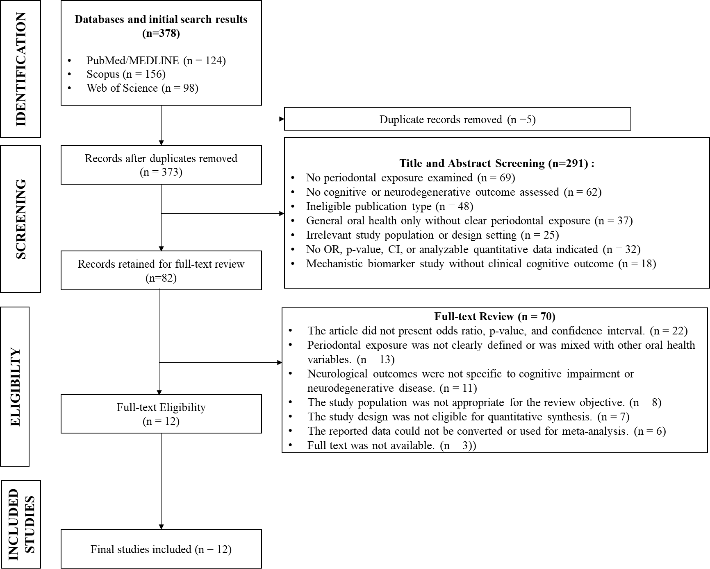
The diagram shows the identification, screening, eligibility assessment, and inclusion process of articles in this systematic review and meta-analysis.

Characteristics of the Included Studies
The 12 included studies were published between 2017 and 2025. The highest number of publications appeared in 2017 and 2025, with three studies in each year. Based on country or data source, Taiwan, South Korea, and the United States were the most common sources. Other studies were conducted in Mexico, Japan, and Spain. Six studies used cohort or population-based cohort designs, while six studies used cross-sectional or observational analytical designs. The most frequently examined outcomes were cognitive impairment, mild cognitive impairment, and amyloid pathology, followed by dementia, Alzheimer disease, vascular dementia, and Parkinson disease. The characteristics of the included studies are summarized in Table 3.
Table 3: Summary of studies on the association of periodontitis with cognitive impairment and neurodegenerative disease.
No. | Author(s) (Year) | Objective | Method | Results | Conclusion
1 | Chen et al. (2017) | To analyze the risk of Alzheimer’s disease in patients with chronic periodontitis. | A retrospective population-based matched cohort study in Taiwan. The sample consisted of 9,291 patients with chronic periodontitis and 18,672 controls without chronic periodontitis. The analysis used Cox proportional hazards regression. | Patients with 10 years of exposure to chronic periodontitis had a higher risk of Alzheimer’s disease than those without chronic periodontitis. The adjusted HR was 1.707; 95% CI = 1.152–2.528; p = 0.0077. | Long-term exposure to chronic periodontitis is associated with an increased risk of Alzheimer’s disease. These findings suggest that periodontal status may be relevant to neurodegenerative outcomes, although causality cannot be inferred.
2 | Y.-T. Lee et al. (2017) | To assess whether periodontitis can serve as a modifiable risk factor for incident dementia. | A prospective cohort study using the Taiwan National Health Insurance Research Database. The sample consisted of 3,028 older adults with periodontitis and 3,028 age- and sex-matched controls. | The risk of dementia was higher in the periodontitis group than in the control group. The HR was 1.16; 95% CI = 1.01–1.32; p = 0.03. | Periodontitis is associated with the risk of new-onset dementia. Periodontal infection may be considered a potentially modifiable oral health factor, although preventive effects require further evidence.
3 | Y.-L. Lee et al. (2017) | To assess the magnitude and temporal aspects of the association between periodontal disease and dementia risk. | A retrospective cohort study based on the Taiwan National Health Insurance Research Database. The sample included 182,747 individuals with newly diagnosed periodontal disease. The analysis compared dental prophylaxis, intensive periodontal treatment, tooth extraction, and no treatment groups. | The incidence of dementia was higher in the untreated periodontal disease group at 0.76% per year and in the tooth extraction group at 0.57% per year. The untreated group had an HR of 1.14; 95% CI = 1.04–1.24. The tooth extraction group had an HR of 1.10; 95% CI = 1.04–1.16. Differences in incidence between groups were significant, with p < 0.001. | More severe or untreated periodontal disease is associated with a higher risk of dementia. Periodontal treatment status may be related to differences in dementia incidence, although causality cannot be inferred.
4 | Choi et al. (2019) | To analyze the association between chronic periodontitis and overall dementia, Alzheimer’s disease, and vascular dementia. | A retrospective cohort study based on the Korean National Health Insurance Service-Health Screening Cohort. The sample consisted of 262,349 participants. The analysis used Cox proportional hazards regression. | Chronic periodontitis was associated with an increased risk of overall dementia, with an aHR of 1.06; 95% CI = 1.01–1.11; p = 0.015. The risk of Alzheimer’s disease also increased, with an aHR of 1.05; 95% CI = 1.00–1.11; p = 0.042. The risk of vascular dementia increased but was not statistically significant, with an aHR of 1.10; 95% CI = 0.98–1.22; p = 0.088. | Chronic periodontitis is associated with a higher risk of dementia and Alzheimer’s disease. The association with vascular dementia appears to increase but is not statistically significant.
5 | Sung et al. (2019) | To analyze the association between periodontitis and impaired cognitive function in the adult population of the United States. | A cross-sectional study using NHANES III. The sample consisted of 4,663 participants aged 20–59 years. Periodontitis status was categorized as normal, mild, moderate, and severe. Cognitive function was assessed using SRTT, SDST, and SDLT. | After adjustment for demographic factors, education, smoking, cardiovascular disease, and laboratory data, periodontitis was significantly associated with increased SDST and SDLT scores. The p for trend was 0.014 for SDST and 0.038 for SDLT. In the fully adjusted model, moderate-to-severe periodontitis was associated with the SDLT total score, with β = 0.146; 95% CI = 0.010–0.282; p = 0.036. | Periodontal status is associated with reduced cognitive function in a national adult sample. Individuals with cognitive impairment require attention in periodontal care.
6 | Jeong et al. (2021) | To evaluate the association between periodontitis and the risk of Parkinson’s disease. | A nationwide retrospective cohort study using data from the South Korean National Health Insurance Service. The final sample consisted of 6,825,684 participants aged ≥40 years. The analysis used the Cox proportional hazards model. | The risk of Parkinson’s disease increased among individuals requiring further dental visits, with an HR of 1.142; 95% CI = 1.094–1.193. The group with periodontitis and a need for further dental visits had the highest risk, with an HR of 1.167; 95% CI = 1.118–1.219. | Periodontitis is associated with an increased risk of Parkinson’s disease. Regular dental and periodontal care may be relevant to broader health management, although its effect on neurodegenerative disease risk remains unconfirmed.
7 | Kim et al, (2022) | To analyze the risk of dementia among older adults with chronic periodontitis according to the severity of periodontitis. | A nationwide retrospective cohort study based on the South Korean National Health Insurance Service-Senior cohort database. After propensity score matching, there were 8,624 patients with mild chronic periodontitis and 8,624 patients with severe chronic periodontitis. | The severe chronic periodontitis group had a higher risk of dementia than the mild chronic periodontitis group. The HR was 1.15; 95% CI = 1.04–1.27; p = 0.009. Kaplan-Meier analysis showed a lower disease-free probability in the severe chronic periodontitis group, with p for log-rank = 0.001. | The severity of chronic periodontitis is associated with an increased risk of dementia. Management of periodontitis from the mild stage may be clinically relevant, although its role in altering dementia risk requires further study.
8 | Luo et al. (2023) | To assess the association of tooth loss and periodontal disease with mild cognitive impairment among Hispanic/Latino immigrants and to examine the role of age at immigration. | An observational study using data from the Hispanic Community Health Study/Study of Latinos. The analyzed immigrant sample consisted of 5,709 participants. The analysis used adjusted regression models. | Severe tooth loss was associated with MCI, with an AOR of 1.36; 95% CI = 1.01–1.85. Overall, periodontal disease was associated with MCI, with p = 0.04. Comparisons of mild, moderate, and severe periodontal disease with no periodontal disease were not significant, with all p values > 0.05. The interaction between periodontal disease and age at immigration was also not significant, with p = 0.10. | Tooth loss appears to be a stronger oral health indicator of MCI than periodontal disease severity. Periodontal disease still shows a general association with MCI.
9 | Igase et al. (2024) | To examine the association between severe periodontitis and mild cognitive impairment among community residents who underwent dental health examinations. | A cross-sectional study involving 321 community participants in Japan. MCI was assessed using the MCI screening test. Periodontitis was diagnosed based on probing pocket depth. The analysis used multivariate logistic regression. | MCI was found in 41 subjects. Severe periodontitis was found in 123 subjects. Severe periodontitis was significantly associated with MCI after including age, education, number of functional teeth, and the presence of severe periodontitis. The OR was 4.024; 95% CI = 1.768–9.161; p < 0.001. | Severe periodontitis is strongly associated with mild cognitive impairment. Patients with severe periodontitis should be considered for cognitive function screening.
10 | Gil-Montoya et al. (2025) | To assess the association between periodontal disease and brain beta-amyloid accumulation in patients with mild cognitive impairment. | An observational study in Spain. All participants underwent periodontal examination and amyloid-PET scanning. The sample consisted of MCI/Aβ+ n = 45, MCI/Aβ− n = 59, and non-MCI/Aβ− n = 60. | Patients with moderate-to-severe periodontitis had a higher risk of abnormal Aβ accumulation. The comparison between MCI/Aβ+ and MCI/Aβ− showed OR = 3.30; 95% CI = 1.30–8.26. The comparison between MCI/Aβ+ and non-MCI/Aβ− showed OR = 4.94; 95% CI = 1.65–14.84. | Periodontal disease is associated with brain beta-amyloid accumulation. These findings support the suspected link between periodontal disease and Alzheimer’s pathology at the MCI stage.
11 | Sun & Li (2025) | To analyze the association between periodontitis and cognitive impairment among older adults in the United States. | A cross-sectional study using NHANES 2011–2014. The sample consisted of 2,514 individuals aged ≥60 years. Periodontitis was categorized as no/mild and moderate/severe. Cognitive function was assessed using CERAD-WL, AFT, and DSST. | A total of 52.6% of the sample had moderate/severe periodontitis. Moderate/severe periodontitis was associated with cognitive impairment on the DSST. The fully adjusted model showed OR = 1.290; 95% CI = 1.021–1.630; p = 0.033. Differences in CERAD-WL and DSST scores across periodontal status were significant, with p = 0.046 and p = 0.010. | Periodontitis is significantly associated with cognitive impairment among older adults. Periodontal care may be considered within older adult health management, although its effect on cognitive decline requires further study.
12 | Aranda Romo et al. (2025) | To determine the correlation between gingival index, periodontitis staging, and mild cognitive impairment assessed using MoCA in adults aged ≥55 years. | A cross-sectional study involving 120 Mexican patients with or without periodontal disease. Periodontal examinations were conducted clinically and radiographically. MCI was assessed using the Montreal Cognitive Assessment. | A total of 54% of subjects had MCI. Loss of clinical attachment level was associated with MCI, with OR = 1.68; 95% CI = 1.06–2.68; p = 0.027. Gingival index was also correlated with MCI, with p = 0.025. Other associated variables were sex, with OR = 2.97; p = 0.015, and education, with OR = 0.37; p = 0.021. | Gingival and periodontal parameters, particularly clinical attachment loss, are associated with mild cognitive impairment in older adults. Periodontal examination may provide additional information for the early detection of cognitive impairment.

Summary of Findings
Several studies reported associations between periodontitis or periodontal disease and cognitive or neurodegenerative outcomes. Cohort studies reported associations between chronic or untreated periodontitis and dementia or Alzheimer disease^{(17-20,23)}. One large nationwide cohort study also reported an association between periodontitis and Parkinson disease⁽²²⁾. Cross-sectional and observational studies reported associations between periodontal disease, clinical attachment loss, severe periodontitis, tooth loss, mild cognitive impairment, cognitive test performance, and beta-amyloid accumulation^{(21,24-28)}. The magnitude and precision of the effect estimates varied across studies, reflecting differences in study design, sample size, periodontal definitions, cognitive outcome measures, comparison groups, and confounding adjustment.

Funnel Plot
The funnel plot was used to assess the distribution of studies based on residual values and standard errors. Some studies were located near the central line, whereas others were positioned farther from the center, indicating visual imbalance. This pattern may be influenced by differences in sample size, study design, outcome type, and statistical measures. Because only 12 studies were included, the funnel plot was interpreted cautiously. The funnel plot is shown in Figure 2.
Figure 2: Funnel plot of the relationship between periodontitis, cognitive impairment, and neurodegenerative disease.
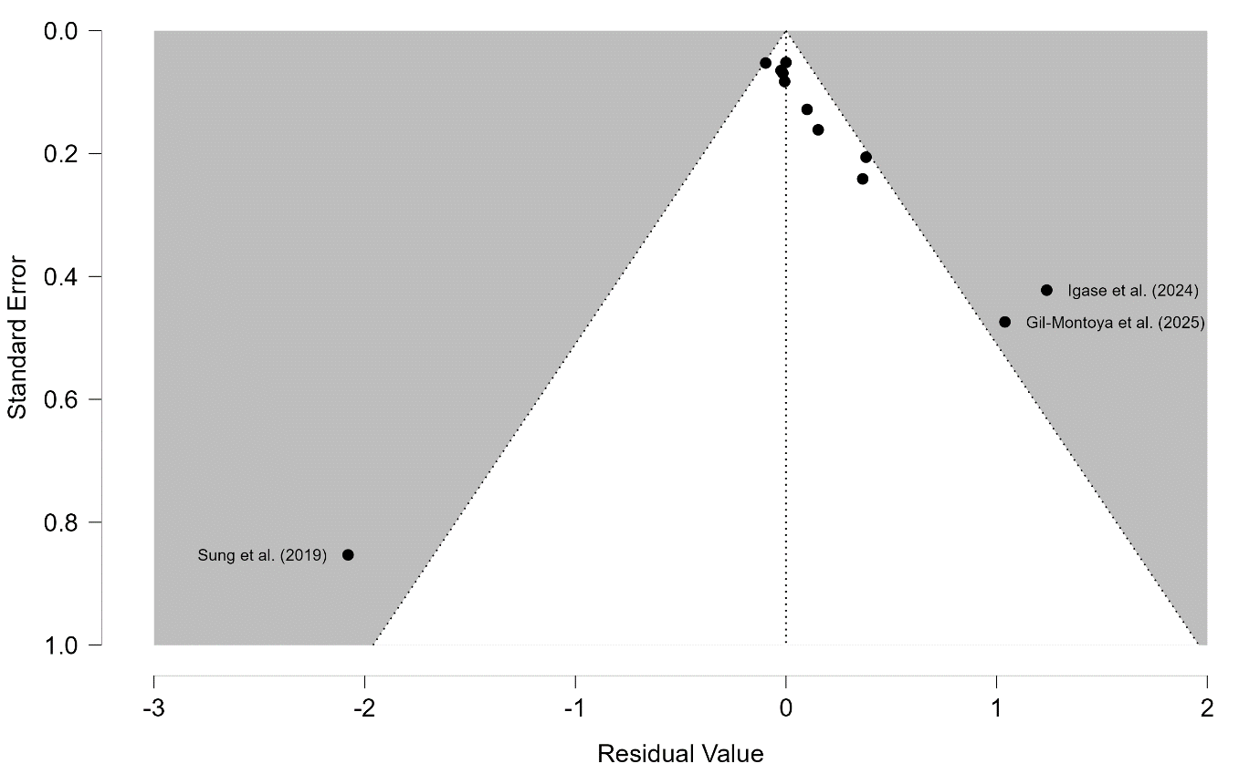
The funnel plot presents the distribution of included studies based on residual values and standard errors to visually assess possible publication bias and variation across studies.

Forest Plot and Pooled Effect
The forest plot showed that most studies had a positive direction of effect. The pooled effect estimate was 0.15, representing a standardized effect size, with a 95% confidence interval of 0.05-0.26 and p=0.007. This finding suggests a statistically significant association between periodontitis and cognitive impairment or neurodegenerative disease. Heterogeneity was significant, with Q(11)=39.24, p<0.001, and I²=72.0%, indicating substantial heterogeneity across the included studies. This heterogeneity should be considered when interpreting the pooled findings because the included studies differed in population characteristics, exposure definitions, outcomes, study designs, and statistical methods. The forest plot is shown in Figure 3.
Figure 3: Forest plot of the association between periodontitis, cognitive impairment, and neurodegenerative disease.
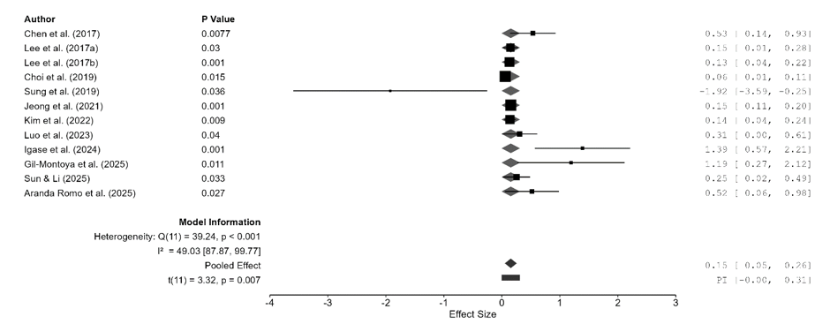
The forest plot presents the effect estimate, confidence interval, pooled effect, and heterogeneity of the included studies.

Discussion
This systematic review and meta-analysis found a statistically significant association between periodontitis and cognitive impairment or neurodegenerative disease. The pooled effect estimate was 0.15, with a 95% confidence interval of 0.05-0.26 and p=0.007. This result suggests that periodontal disease may be related to cognitive and neurodegenerative outcomes. However, interpretation should be cautious because the included studies differed in exposure definitions, outcome categories, study designs, comparison groups, and effect measures.
The findings are consistent with previous evidence showing associations between poor periodontal health, cognitive decline, and dementia⁽⁶⁻⁹⁾. Several cohort studies included in this review reported associations between chronic, untreated, or severe periodontitis and dementia or Alzheimer disease^{(17-20,23)}. In addition, cross-sectional studies reported associations between periodontal parameters and cognitive outcomes^{(21,24-28)}. These findings suggest that periodontal status may be relevant to cognitive health, although the direction and magnitude of the association remain uncertain.
Potential biological pathways include inflammatory, microbial, vascular, and immune mechanisms. Periodontal pathogens and inflammatory mediators may contribute to systemic inflammation, endothelial dysfunction, oxidative stress, and neuroinflammation. The oral-brain axis and the potential role of P. gingivalis have been proposed as plausible mechanisms⁽³⁻⁵⁾. Nevertheless, biological plausibility does not establish causality, and epidemiological findings must be interpreted in light of study design and confounding.
The relationship between periodontitis and neurodegenerative disease may differ according to neurological outcome. Evidence appeared more consistent for dementia and Alzheimer disease, whereas evidence for Parkinson disease was limited to one included study. Mild cognitive impairment and beta-amyloid accumulation may represent earlier or more specific markers of cognitive deterioration, but they are clinically distinct from dementia and Parkinson disease. Pooling these outcomes into one overall estimate therefore reduces specificity and may contribute to heterogeneity.
The heterogeneity observed in this meta-analysis was substantial. The included studies differed in periodontal exposure definitions, including clinical periodontitis, chronic periodontitis, severe periodontitis, clinical attachment loss, periodontal treatment status, and tooth loss related to periodontal disease. They also differed in outcome assessment, using clinical diagnosis, registry data, medical records, cognitive tests, and imaging-based methods. These differences may explain variation in effect estimates and should be considered when interpreting the pooled result.
Residual confounding and reverse causality are important concerns. Age, sex, education, smoking, diabetes, socioeconomic status, depression, cardiovascular disease, oral hygiene behavior, dental service access, and general health status may influence both periodontal disease and cognitive outcomes. Although several included studies adjusted for some confounders, residual confounding may still have influenced the observed associations. Cognitive impairment may also reduce oral hygiene and dental care attendance, which may worsen periodontal status after cognitive decline has already begun.
Publication bias should also be considered. Although a funnel plot was presented, its interpretation was limited because only 12 studies were included. With a small number of studies, funnel plot asymmetry is difficult to evaluate reliably. Therefore, the possibility of publication bias cannot be excluded and may have influenced the overall interpretation of the evidence.
This study has several limitations. First, most included studies were observational, limiting causal interpretation. Second, periodontal exposure definitions varied across studies. Third, cognitive and neurodegenerative outcomes were measured using different instruments and diagnostic methods. Fourth, the included studies used different statistical measures, including odds ratios, adjusted odds ratios, hazard ratios, adjusted hazard ratios, and beta coefficients. Fifth, heterogeneity across studies was significant. Subgroup analysis according to outcome type, study design, exposure definition, or statistical measure was not performed; therefore, the sources of heterogeneity could not be explored in detail. Sixth, the certainty of evidence was not formally assessed using the GRADE framework. Finally, restricting the search to studies published from 2017 to 2025 may have excluded relevant earlier evidence.
Future studies should use longitudinal designs with longer follow-up periods, standardized periodontal definitions, repeated cognitive assessments, and careful adjustment for confounding factors. Future reviews should consider separate analyses according to outcome type, study design, exposure definition, and effect measure rather than pooling clinically distinct outcomes into one broad estimate. Further studies incorporating inflammatory biomarkers, periodontal pathogen profiles, and standardized neurocognitive assessments may help clarify the biological pathways linking periodontal disease and cognitive or neurodegenerative outcomes.

Conclusion
Periodontitis and periodontal disease may be associated with cognitive impairment and neurodegenerative disease. However, the available evidence supports an association rather than a confirmed causal or preventive effect. Because the included studies were clinically and methodologically heterogeneous, the findings should be interpreted cautiously. Further longitudinal studies with standardized periodontal and cognitive outcome measures, careful control of confounding factors, and separate analyses by neurological outcome are needed to clarify the strength and direction of this association.

Author Contributions
- Conceptualization and study design: Yoifah Rizka Wedarti, Soetjipto, and Agung Krismariono.
- Literature search, study screening, data extraction, and data curation: Yoifah Rizka Wedarti, Soetjipto, and Agung Krismariono.
- Formal analysis and interpretation: Yoifah Rizka Wedarti and Soetjipto.
- Manuscript drafting: Yoifah Rizka Wedarti.
- Critical review, supervision, and final approval: Yoifah Rizka Wedarti, Soetjipto, and Agung Krismariono.

Acknowledgements
The authors received no specific financial support for this study. No non-author contributors were involved in the preparation of this manuscript.

Conflict of Interest
The authors declare no potential conflicts of interest with respect to the authorship and/or publication of this article.

Ethical Approval
Ethical approval was not required because this study was a systematic review and meta-analysis based on previously published studies and did not involve direct recruitment of human participants, collection of biological samples, or animal experiments.

Declaration of Generative AI and AI-assisted Technologies in the Writing Process
Author(s) used ChatGPT for language editing, formatting, and improvement of readability during the preparation of this manuscript. The outcomes after using this AI tool were reviewed and edited by the authors, who declare their full responsibility for the content, data interpretation, references, conclusions, and integrity of this work.

References
1. World Health Organization. Oral health [Internet]. Geneva: World Health Organization; 2025 [cited 2026 Jun 5]. Available from: https://www.who.int/news-room/fact-sheets/detail/oral-health
2. World Health Organization. Dementia [Internet]. Geneva: World Health Organization; 2025 [cited 2026 Jun 5]. Available from: https://www.who.int/news-room/fact-sheets/detail/dementia
3. Li R, Wang J, Xiong W, Luo Y, Feng H, Zhou H, et al. The oral-brain axis: can periodontal pathogens trigger the onset and progression of Alzheimer’s disease? Front Microbiol. 2024;15:1358179. doi:10.3389/fmicb.2024.1358179.
4. Huang Z, Hao M, Shi N, Wang X, Yuan L, Yuan H, et al. Porphyromonas gingivalis: a potential trigger of neurodegenerative disease. Front Immunol. 2025;16:1482033. doi:10.3389/fimmu.2025.1482033.
5. Jiang Y, Xu L, Zhao X, Shen H, Qiu C, He Z, et al. Porphyromonas gingivalis-induced periodontitis promotes neuroinflammation and neuronal loss associated with dysfunction of the brain barrier. Front Cell Infect Microbiol. 2025;15:1559182. doi:10.3389/fcimb.2025.1559182.
6. Asher S, Stephen R, Mäntylä P, Suominen AL, Solomon A. Periodontal health, cognitive decline, and dementia: a systematic review and meta-analysis of longitudinal studies. J Am Geriatr Soc. 2022;70(9):2695-2709. doi:10.1111/jgs.17978.
7. Said-Sadier N, Sayegh B, Farah R, Abbas LA, Dweik R, Tang N, et al. Association between periodontal disease and cognitive impairment in adults. Int J Environ Res Public Health. 2023;20:4707. doi:10.3390/ijerph20064707.
8. Dibello V, Custodero C, Cavalcanti R, Lafornara D, Dibello A, Lozupone M, et al. Impact of periodontal disease on cognitive disorders, dementia, and depression: a systematic review and meta-analysis. GeroScience. 2024;46(5):5133-5169. doi:10.1007/s11357-024-01243-8.
9. Fu YD, Li CL, Hu CL, Pei MD, Cai WY, Li YQ, et al. Meta analysis of the correlation between periodontal health and cognitive impairment in the older population. J Prev Alzheimers Dis. 2024;11. doi:10.14283/jpad.2024.87.
10. Plachokova AS, Gjaltema J, Hagens ERC, Hashemi Z, Knüppe TBA, Kootstra TJM, et al. Periodontitis: a plausible modifiable risk factor for neurodegenerative diseases? A comprehensive review. Int J Mol Sci. 2024;25(8):4504. doi:10.3390/ijms25084504.
11. Villar A, Paladini S, Cossatis J. Periodontal disease and Alzheimer’s: insights from a systematic literature network analysis. J Prev Alzheimers Dis. 2024;11(4):1148-1165. doi:10.14283/jpad.2024.79.
12. Barbarisi A, Visconti V, Lauritano D, Cremonini F, Caccianiga G, Ceraulo S. Correlation between periodontitis and onset of Alzheimer’s disease: a literature review. Dent J. 2024;12(10):331. doi:10.3390/dj12100331.
13. Erlianti CP, Trihandini I. Factors associated with cognitive impairment among Indonesian older adults. Aging Med Healthc. 2024;15(3):105-113. doi:10.33879/AMH.153.2022.05048.
14. van der Ploeg ES, Handajani YS, Schröder-Butterfill E. Dementia care in Indonesia: care networks, awareness & perception. J Cross Cult Gerontol. 2025;40(4):441-461. doi:10.1007/s10823-025-09544-x.
15. Page MJ, McKenzie JE, Bossuyt PM, Boutron I, Hoffmann TC, Mulrow CD, et al. The PRISMA 2020 statement: an updated guideline for reporting systematic reviews. BMJ. 2021;372:n71. doi:10.1136/bmj.n71.
16. Higgins JPT, Thomas J, Chandler J, Cumpston M, Li T, Page MJ, et al, editors. Cochrane handbook for systematic reviews of interventions. Version 6.5. Cochrane; 2024. Available from: https://training.cochrane.org/handbook
17. Chen CK, Wu YT, Chang YC. Association between chronic periodontitis and the risk of Alzheimer’s disease: a retrospective, population-based, matched-cohort study. Alzheimers Res Ther. 2017;9:56. doi:10.1186/s13195-017-0282-6.
18. Lee YT, Lee HC, Hu CJ, Huang LK, Chao SP, Lin CP, Su ECY, et al. Periodontitis as a modifiable risk factor for dementia: a nationwide population-based cohort study. J Am Geriatr Soc. 2017;65(2):301-305. doi:10.1111/jgs.14449.
19. Lee YL, Hu HY, Huang LY, Chou P, Chu DK. Periodontal disease associated with higher risk of dementia: population-based cohort study in Taiwan. J Am Geriatr Soc. 2017;65(9):1975-1980. doi:10.1111/jgs.14944.
20. Choi S, Kim K, Chang J, Kim SM, Kim SJ, Cho HJ, et al. Association of chronic periodontitis on Alzheimer’s disease or vascular dementia. J Am Geriatr Soc. 2019;67(6):1234-1239. doi:10.1111/jgs.15828.
21. Sung CE, Huang RY, Cheng WC, Kao TW, Chen WL. Association between periodontitis and cognitive impairment: analysis of National Health and Nutrition Examination Survey III. J Clin Periodontol. 2019;46(8):790-798. doi:10.1111/jcpe.13155.
22. Jeong E, Park JB, Park YG. Evaluation of the association between periodontitis and risk of Parkinson’s disease: a nationwide retrospective cohort study. Sci Rep. 2021;11:16594. doi:10.1038/s41598-021-96147-4.
23. Kim SR, Son M, Kim YR, Kang HK. Risk of dementia according to the severity of chronic periodontitis in Korea: a nationwide retrospective cohort study. Epidemiol Health. 2022;44:e2022077. doi:10.4178/epih.e2022077.
24. Luo H, Wu B, González HM, Stickel A, Kaste LM, Tarraf W, et al. Tooth loss, periodontal disease, and mild cognitive impairment among Hispanic/Latino immigrants: the moderating effects of age at immigration. J Gerontol A Biol Sci Med Sci. 2023;78(6):949-957. doi:10.1093/gerona/glac178.
25. Igase M, Igase K, Hino S, Uchida D, Okada Y, Ochi M, et al. Association of periodontitis with mild cognitive impairment in older adults. J Aging Res Lifestyle. 2024;13:108-112. doi:10.14283/jarlife.2024.16.
26. Gil-Montoya JA, Gerez-Muñoz MJ, Triviño-Ibáñez E, Carrera-Muñoz I, Bravo M, Rashki M, et al. Periodontal disease and brain amyloid pathology in mild cognitive impairment. Neurologia. 2025;40(7):641-650. doi:10.1016/j.nrleng.2025.07.008.
27. Sun Q, Li M. Association between periodontitis and cognitive impairment in older adults: a cross-sectional study of the National Health and Nutrition Examination Survey. Clin Epidemiol Glob Health. 2025;33:102020. doi:10.1016/j.cegh.2025.102020.
28. Aranda Romo S, Garrocho-Rangel A, Marín González A, Cepeda-Bravo A, Jiménez-Capdeville ME, Ortega Rodríguez C, et al. Cognitive status and periodontitis: is there a correlation? A cross-sectional study. Dent Med Probl. 2025;62(4):591-600. doi:10.17219/dmp/177412.

